

**Helwan University**

**Faculty of Computers and Artificial Intelligence**

**Software Engineering Program**

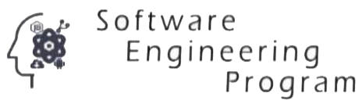

[Project Title]

A graduation project dissertation by:

[ Student Name 1 ( Student ID ) ]

[ Student Name 2 ( Student ID ) ]

[ Student Name 3 ( Student ID ) ]

[ Student Name 4 ( Student ID ) ]

[ Student Name 5 ( Student ID ) ]

Submitted in partial fulfilment of the requirements for the degree of Bachelor of Science in Computers & Artificial Intelligence, at the Software Engineering Program, the Faculty of Computers & Artificial Intelligence, Helwan University

Supervised by:

**[ Dr. Supervisor’s Name ]**

June 2023